Noble County Community Fair 2019 Reservation Form

IMPORTANT DATES FOR 2019:
- Reserve your previous campsite or guarantee a spot by submitting form and down payment of $50.00 by May 1st.
- Remaining balance of $100.00 will be due on or before June 15th.
- Failure to make payments will result in forfeiture of campsite locations.
- Any reservations made after June 15th will be charged a late fee of $25.00, and will be enforced!
- Your reservation will be emailed by July 1st if email is provided. All others may call after July 1st for location assignment.

Camping Rules
- Check in with a member of the camping committee, at fair office, before unhitching at your campsite.
- Must follow all general rules of the NCCFC fair week, which are:
  - No alcohol or weapons are to be permitted on fairgrounds at any time.
  - No smoking in buildings.
  - Pets must remain at campsite. If found to be a nuisance, you will be asked to take them home. No animals tied to electrical outlets or water hook-ups.
  - No bicycles, skateboards, roller blades, or skates on the grounds.
  - Livestock trailers must be parked in designated areas.
  - Campers must be parked in assigned areas.
  - Only approved motorized ATVs will be allowed on fairgrounds. Please see website for more information.
- Quiet hours are from 11:00 pm to 6:00 am.
- No fair animals at campsites.
- No roping off campsites.
- You will receive one camper tag. The camper tag is to be displayed in your camper during the duration of the fair. You will also receive one camper vehicle tags that will get you into the fair all week! These tags do not guarantee parking next to your camper.
- Under the terms of admission, you enter the fairgrounds at your own risk and responsibility.
- Minors must camp with and be supervised by a responsible adult.
- All campfires must be in a pit or fire ring weather permitted. No campfires or stoves to be left unattended.
- Campers are responsible for taking their trash to the DUMPSTERS in the camping area. No small trash cans will be emptied in the camping area.
- The dumping station is located south of the main gate between the cinder block restrooms.
- Camping fees: $30.00 per day or $150.00 for the week. Tent camping will be in designated areas and charged a rate of $7.50 a night or $75.00 for the week.
- Campers are to be brought to the Fairgrounds Thursday, July 11th - Sunday, July 14th. Anytime before this will be charged the extra fee of 30.00 per day!
- All campers should be removed before sunset on July 21st, 2019.

Please return this page and send with payment:

Campers Name:______________________________________________________________________
Campers Address: ____________________________________________________________________
Campers Phone: Home- ________________________ Cell- __________________________
Email address for correspondence: _____________________________________________________________
If you camped last year would you like the same site? Yes No Size of Unit _________________
Please list your preference near a barn by designating in numerical order where you would like to be camping near. Only complete this section if you are a new or returning camper wishing to move. New campers will be placed according to their preference, and availability.
___ A Water and Electricity ___ E Water and Electricity
___ B Water in most locations and Electricity ___ F Tent Camping Only
___ C Water at west end and center, Electricity ___ G Water and Electricity
___ D No Water, Electricity only ___ H Water and Electricity

Special Instructions: _______________________________________________________________________
______________________________________________________________________________________________________________________________________________________________________________________________________________________________________________________________________________

By signing this form you abide by the rules and regulations of the Noble County Community Fair Corporation. If you do not follow the rules and regulations or cause ANY problems, you will be asked to remove your camping unit from the grounds, with NO return.

Camper's Signature: _________________________________________ Date: _________________________
Make Check Payable to NCCFC
Final Registration Deadline: June 15th, 2019
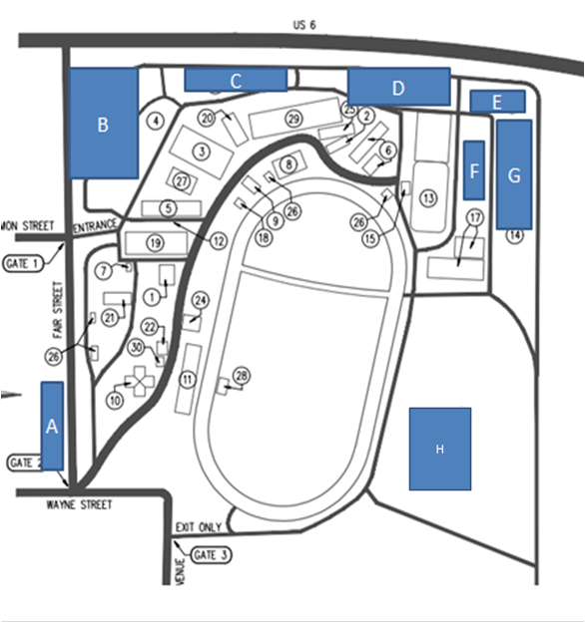
Khara Kimmel- 5701 E. 250 South Avilla, IN 46710 (317-902-1796)

